**PRACTICAL NO – 1**

**INTRODUCTION DESCRIPTION AND TO WIKIPEDIA**

**NAME – Manav Rajesh Shetty**

**ROLL NO – 84**

**CLASS – FYIT**

**1)DESCRIPTION ABOUT WIKIPEDIA AND ITS FEATURE**

**DESCRIPTION :**

Wikipedia was launched on January 15, 2001 by [Jimmy Wales](https://en.wikipedia.org/wiki/Jimmy_Wales) and [Larry Sanger](https://en.wikipedia.org/wiki/Larry_Sanger). Sanger coined its name as a [portmanteau](https://en.wikipedia.org/wiki/Portmanteau) of "[wiki](https://en.wikipedia.org/wiki/Wiki)" and "encyclopaedia". It was initially an [English-language encyclopaedia](https://en.wikipedia.org/wiki/English_Wikipedia), but versions in [other languages](https://en.wikipedia.org/wiki/List_of_Wikipedias) were quickly developed. With 6.2 million articles, the English Wikipedia is the largest of the 317 Wikipedia encyclopaedias. Overall, Wikipedia comprises more than 55 million articles, attracting 1.7 billion unique visitors per month.

**FEATURES** **:**

Wikipedia [has been criticized](https://en.wikipedia.org/wiki/Criticism_of_Wikipedia) for its uneven accuracy and for exhibiting [systemic bias](https://en.wikipedia.org/wiki/Criticism_of_Wikipedia#Systemic_bias_in_coverage), including [gender bias](https://en.wikipedia.org/wiki/Gender_bias_on_Wikipedia), with the majority of editors being [male](https://en.wikipedia.org/wiki/Male) [Edit-a-thons](https://en.wikipedia.org/wiki/Edit-a-thon) have been held to encourage female editors and increase the coverage of women's topics. In 2006, [*Time*](https://en.wikipedia.org/wiki/Time_(magazine)) magazine stated that the open-door policy of allowing anyone to edit had made Wikipedia the biggest and possibly the best encyclopaedia in the world, and was a testament to the vision of Jimmy Wales. The project's reputation improved further in the 2010s as it increased efforts to improve its quality and reliability, based on its unique structure, curation and absence of commercial bias. In 2018, [Facebook](https://en.wikipedia.org/wiki/Facebook) and [YouTube](https://en.wikipedia.org/wiki/YouTube) announced that they would help users detect [fake news](https://en.wikipedia.org/wiki/Fake_news) by suggesting links to related Wikipedia articles

2)CREATING ACCOUNT ON WIKIPEDIA

STEP 1: Fill your details in the given space and enter the captcha

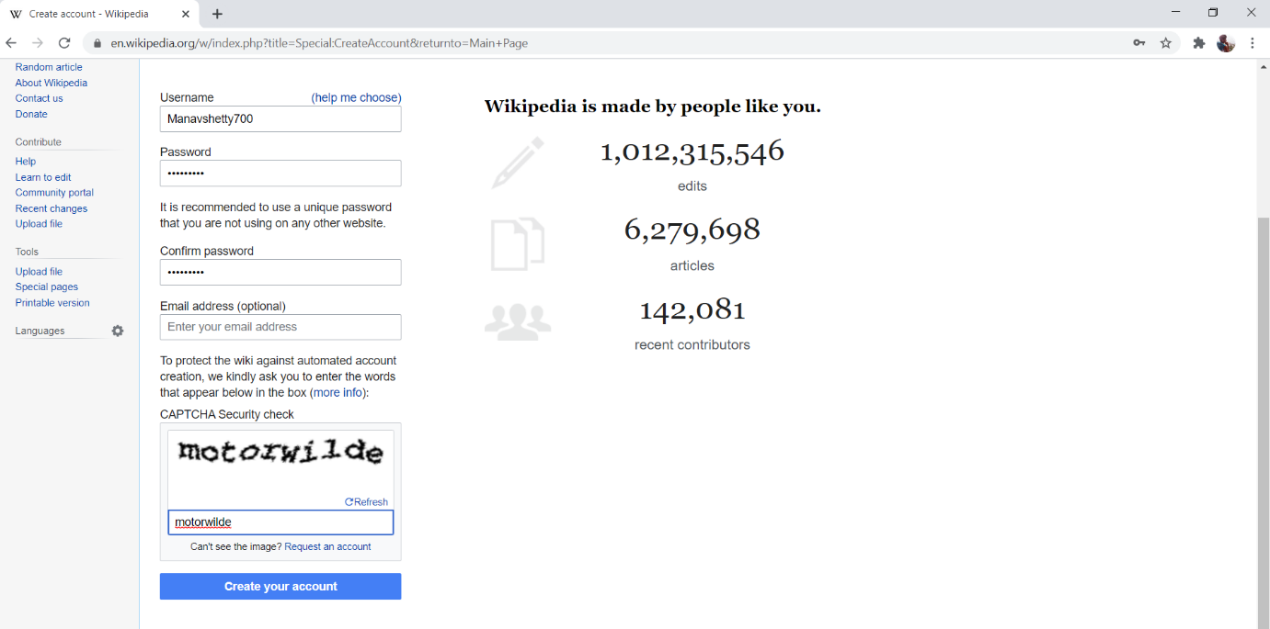

STEP 2: This account is created

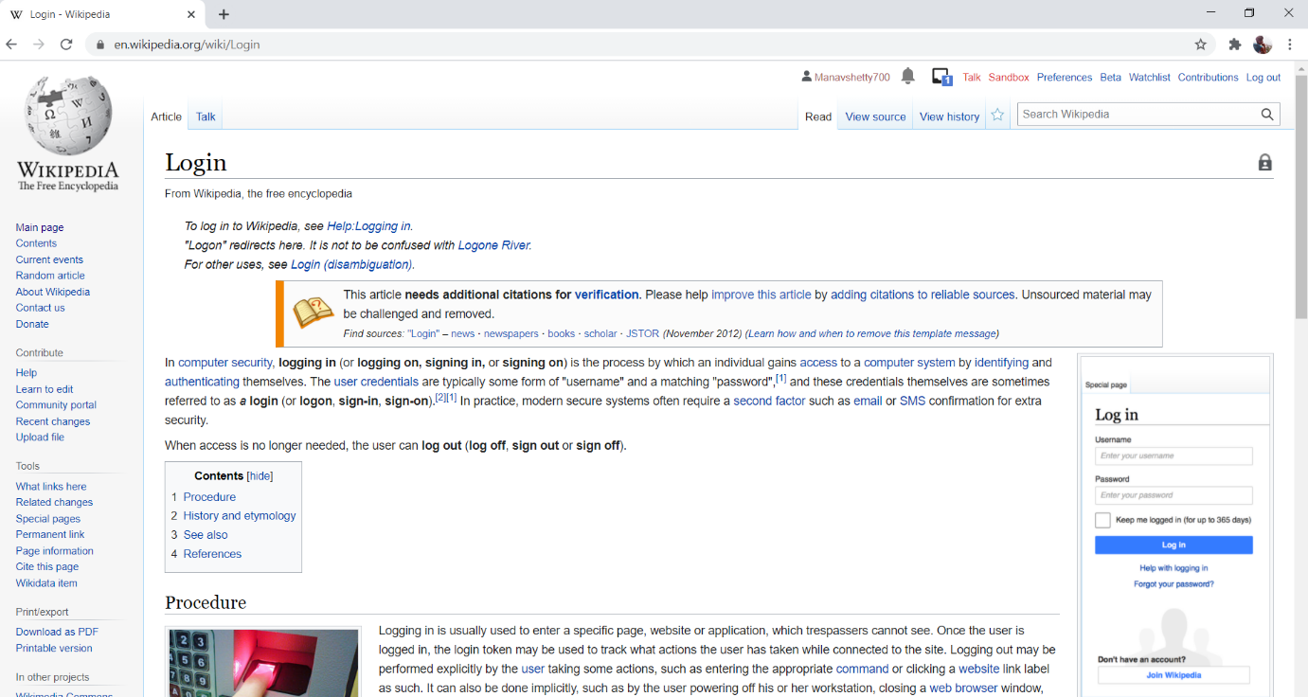

3) **CREATED OUR OWN PAGE**

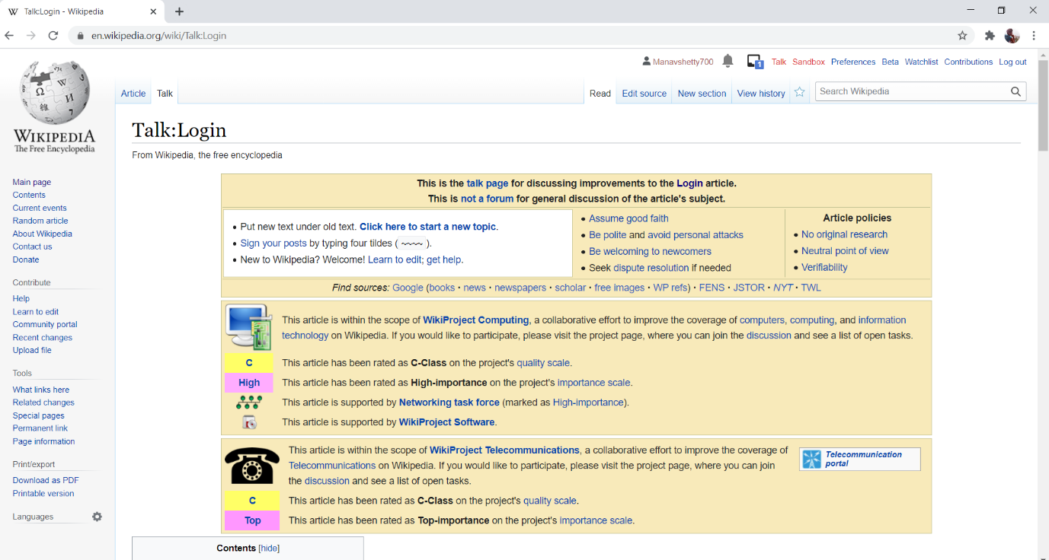

4) EDITING YOUR OWN PAGE ON WIKIPEDIA

